Electron Beam Ion Traps

# Principles

Components: e-gun, solenoidal magnets, axial electrostatic trap, e-collector

Primary Purpose: Charge Breeds Ions through electron impact ionization

Electron beam is generated, and compressed through ion trapping region and collected on the other side.

Ions can be injected, or generated with ambient gas in vacuum vessel.

Cylindrical electrostatic plates centered on axis provide axial confinement. The uniformity and depth of the electrostatic well within the trap can also be adjusted.

Radial confinement performed by the space-charge potential of the e-beam.

Keep in mind that in order to accelerate the beam, the whole source, and all of it’s components must be kept on a voltage platform.

Keeping it all at 4K helps reduce contamination and allows feasible magnet design for a longer trapping region.

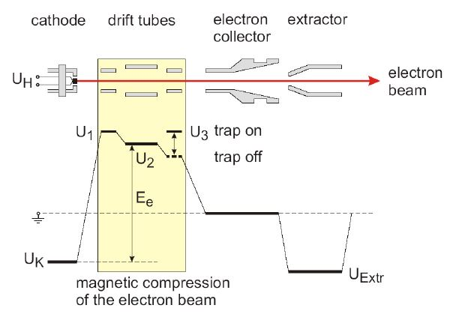

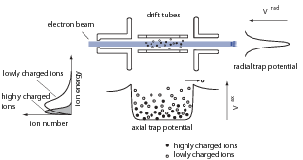

# Key Parameters

Magnetic Field: ~4T

E-Beam Current: <1.4A, but typically ran around 300mA for stable operation

…child-langmuir law:  (V anode, d dist cathode->anode) And perveance of our source ~0.85*10-6 A/V^3/2

Current density: (@300mA) ~170A/cm^2

E-Beam energy: < 30 keV (e.g., Ne-like U82+) …Ee = e(U2 - UK + Ue);

Length of Trapping Region: ~0.64m

# Ion Production

Rates q=1: dno/dt = -λ_1 n_0, and to q: dnq/dt = λ_q n_(q-1) – λ_(q+1) n_q

Reaction rate: σq = σqvene (reaction rate) [s^-1] …w/ σ ionization cross-section, electron velocity, & electron density

Characteristic time τ for ion production 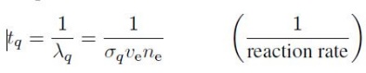, 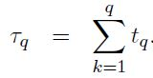, 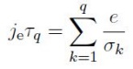

Require Ee > (2-3) x Ionization Potential of electron

And sufficiently high Ionization Factor

Impact Ionization

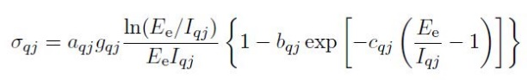, with a = 4.5x10-14 cm^2 eV^2, and b=c=0 for highly charged ions

J index for subshell, I_qj ionization potential, g_qj occupation number. 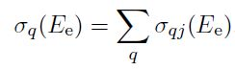 (overall cross section for charge state).

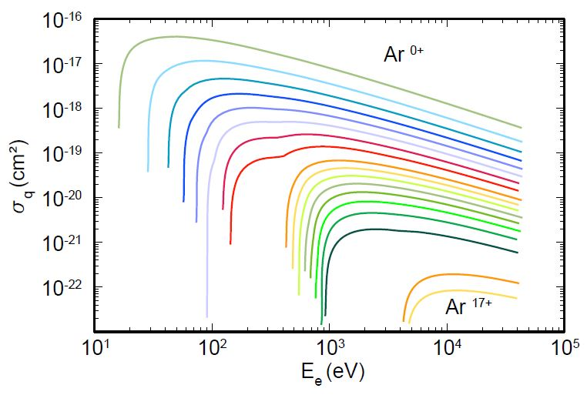

Charge Recombination

, 

Charge exchange is high, 10^-14-10^-15 [cm^-2] for exchange to neutrals. Cross section decreases with increasing ionization potential. Is dominant loss mechanism.

Example

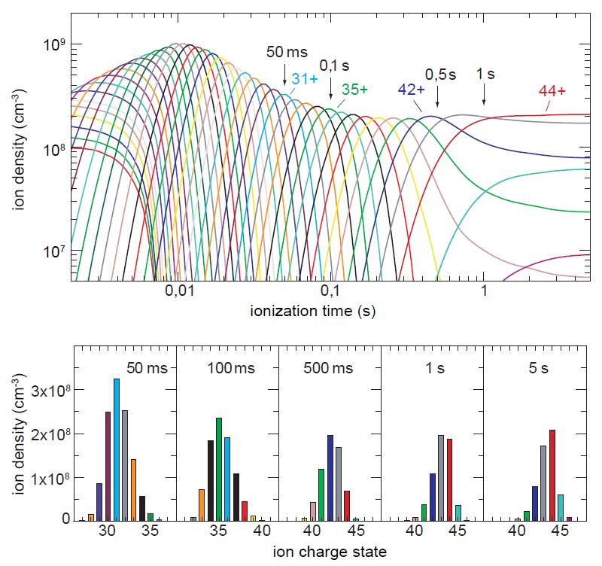

# Mass Separator

Coordinate Transformation, emittance is conserved, energy and mass are dispersed at focus locations for separating desired energy and mass.

Some numbers, 25% single charge state efficiency, 80% all charge states

(x,dE) = (x,dM) = 10 mm/%, emittance of about

**Resources**

Electron Beam Ion Soures, G. Zschornack, M.Schmidt and A.Thorn

First two years of on-line operation of the ReA EBIT charge breeder, A. Lapierre et.al.